Module 3 (HTML 5)

1. What are the new tags added in HTML5?

|  |  |
| --- | --- |
| 1.article | 13.nav |
| 2.aside | 14.output |
| 3.audio | 15.section |
| 4.canvas | 16.sourch |
| 5.command | 17.summary |
| 6.detailst | 18.svg |
| 7.embed | 19.time |
| 8.figcaptio | 20.track |
| 9.figure | 21.video |
| 10.footer |  |
| 11.header |  |
| 12.mark |  |

4 canvas

5 command

6 detailst

7 embed

1. figure

1. How to embed audio and video in a webpage?

HTML 5 provides two tags: <audio> and <video>

Tags using which we can add the audio or video

Directly in the webpage.

Example.

<video src="Pexels Videos 2022395.mp4"

controls></video>

<audio src="song.mp4" controls </audio>

1. Semantic element in HTML5?

In HTML there are some semantic elements that can be used to define different parts of a web page:

EXAMPLE;

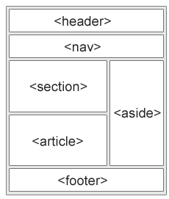

<article>

<aside>

<details>

<figcaption>

<figure>

<footer>

<header>

<main>

<mark>

<nav>

<section>

1. Canvas and SVG tags

The <canvas> tag in HTML is used to draw graphics on a web page using JavaScript. It can be used to draw paths, boxes, texts, gradients, and adding images. By default, it does not contain borders and text.

EXAMPLE;

<canvas id = "script"> Contents... </canvas>

The HTML <svg> element is a container for SVG graphics.

SVG has several methods for drawing paths, boxes, circles, text, and graphic images.

EXAMPLE;

<svg width="100" height="100">  
  <circle cx="50" cy="50" r="40" stroke="green" stroke-width="4" fill="yellow" />  
</svg>